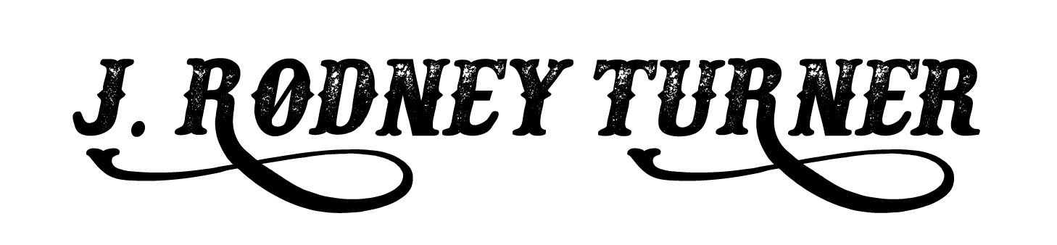

[Rodney@jrodneyturner.com](mailto:Rodney@jrodneyturner.com)

<https://www.jrodneyturner.com>

Phone: 615.509.8360

***Over 200 Audiobooks & more around the corner…..***

***Audiobook Titles – (Partial List)***

***Westerns***

***The First Mountain Man Series*** by William W. Johnstone & JA Johnstone / Tantor Audio

***The Mountain Man Series*** by William W. Johnstone & JA Johnstone / Tantor Audio

***The Red Ryan Series*** by William W. Johnstone & JA Johnstone / Tantor Audio

***Preacher and MacCallister Series*** by William W. Johnstone & JA Johnstone / Tantor Audio

***Have Brides, Will Travel Series*** by William W. Johnstone & JA Johnstone / Tantor Audio

***Sheriff Aaron Mackey Series*** by Terrence McCauley / Tantor Audio

***The Whicher Series*** by John Stonehouse / Findaway Voices

***Judge and Drury Series*** by Ben Bridges / Audiobook Creation Exchange

***Horror***

***Hell Hollow*** by Ronald Kelly, Crossroads Press / ACX

***Undertaker’s Moon*** by Ronald Kelly; Crossroads Press / ACX

***Fear*** by Ronald Kelly; Crossroads Press / ACX

***Mystery Thrillers***

***The Jim Buchanan Novels*** by Felix F. Giordano / ACX

***The Wyatt Storme Thriller*** series by W. L. Ripley / Brash Books / ACX

***Romance***

***Zebra Historical Romance Series*** by Janette Kenny / ACX

***All Roads Lead Home Series*** by LL Ward / ACX

***Vintage Love Stories*** by 8 authors and 9 narrators / Blunder Woman Productions

***Non-Fiction***

***Dirty Dealing; Drug smuggling on the Mexican Border and The Assassination of a Federal Judge***

By Gary Cartwright / Tantor Audio

***Crossing the Aisle; How Bipartisanship Brought Tennessee To the 21st Century and could Save America***

By Keel Hunt / Knack Factory

***Classic Westerns – Zane Grey***

***The UP Trail*** – ACX / Raging Bull Publishing

***The Young Lion Hunter*** – ACX / Raging Bull Publishing

***The Last of the Plainsmen*** – Spoken Realms

***The Rustlers of Pecos County*** – Spoken Realms

***Desert Gold*** – Spoken Realms

***The Ohio River Valley Trilogy*** – ACX / Raging Bull Publishing

***Betty Zane; the Spirit of the Border; The Last Trail***

***Education and Training***

Coaches: ***Johnny Heller*** – Fiction and The Author’s Truth; ***Scott Brick*** – Performance and developing characters; ***Carol Monda*** – Developing female characters and performance; ***David H Lawrence XVII*** – The Art, Science, and Commerce of Voice Acting; ***Sean Pratt*** – The Non-Fiction Curriculum; ***Patrick Fraley*** – Getting inside the character’s head; ***Paul Ruben*** – Less is More; ***Paula Parker*** – working with a booth director

***Equipment / Software***

27” iMac; Audient iD22; Neumann U87; Audacity and OcenAudio