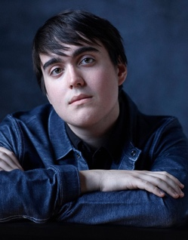
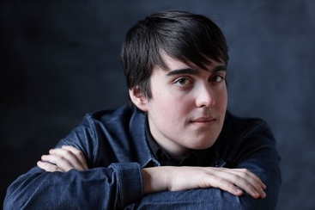
EDEN GABAY
202-878-1503
edensaig@gmail.com
Height: 6’0” Eye Color: Green Hair Color: Black Age: 24
Voiceover:______________ _____________________________________________________________
Angelique and Other Stories – Audiobook Solo – Alicia Cameron
Ursilla and the Baron’s Revenge – Audiobook Solo – Alicia Cameron
New Haven – Audiobook Solo – Dr. Adam Kirstein
Vermillion Flames – Audiobook Solo – Adam Fernandez
An Armenian in Cyprus – Audiobook Solo – Garabed Kiremidjian
Frankenstein (Abridged) – Audiobook Solo – Mary Shelley (Abridging by Brock Parks)
Shahrazad – Audiobook Duet – Jocelyn Murray
Zniper: A Sniper’s Journey Through the Apocalypse – Audiobook Duet – C. Ward III
The Fall of Ingway – Melisahn, Vanity, Various Characters – Full Cast Audio Drama – Justin Rose
Nigel Hawkes, Music Historian – Higher Grounds – Podcast Drama
Hot Pursuit – Audiobook Duet – Kay Marie
Stolen Goods – Audiobook Duet – Kay Marie
Granted – Audiobook Duet – Ellis Summers
The Indian and Me – Audiobook Duet – Cathy Peebles
The Thief and Me – Audiobook Duet – Cathy Peebles
Mean Little People – Audiobook – Paige Dearth
Raven Ledger Books 1 and 2 – Audiobook – Paige Dearth
Eight Weeks Later – Audiobook – GT London
Roses in Red Wax – Audiobook – Louise Mayberry
Swept Into the Storm – Audiobook – Louise Mayberry
Training:___________ __________________________________________________________ ______

New York University, Tisch School of the Arts – Graduated September 2022, Magna Cum Laude w/Honors in Theatre
International Theater Workshop (2022) - New York University, Tisch School of the Arts Amsterdam, The Netherlands
Stonestreet Studios (2021) - New York University, Tisch School of the Arts New York, NY
The Classical Studio (2020-2021) - New York University, Tisch School of the Arts New York, NY
Experimental Theatre Wing (2018-2020) - New York University, Tisch School of the Arts New York, NY
Special Skills:_____________________ ____________________________ ________________ __
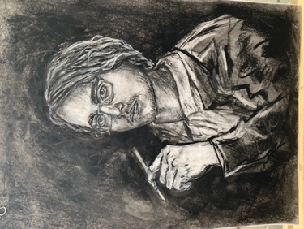
Shakespeare specialist; Composer; Dialects Expert; Stage Combat; Impressionist (Alan Alda, Donald Trump, JFK, All 4 Beatles, Jim Browning, Gilbert Gottfried, Johnny Cash); Works in US, UK and Australia; Full Audio Production (Fully Sound Proofed Booth, 2 Neumann TLM103s, USB PRE-2, Avalon V5. Izotope RX, Vocal Rider, Reaper)

